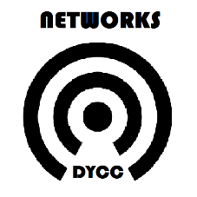

**Networks Referral Form** for young people who are at risk of becoming, or are already Not in Education, Employment or Training (NEET). Once completed please email back to sarah.davies@dycc.org.uk.

|  |  |
| --- | --- |
| **Name of Young Person (YP)** |  |
| **DOB** |  |
| **Address**  **Postcode** |  |
| **Does the YP have any diagnosed additional needs and/or SEND?** *(e.g., ADHD, ASC, long term illness)* |  |
| **Name of School/College/Alternative Provision or currently NEET?** |  |
| **Can we contact**  **School/College/Alternative Provision?**  *\*If yes please provide contact details.* |  |
| **Can we contact Parents/Carers?**  *\*If yes please provide contact details.* |  |
| **Reason for Referral** |  |
| **Is the YP currently under any other services*?***  *(e.g., Counselling, Therapeutic Groups)* |  |
| **Is the YP currently on any waiting lists?**  *(e.g., CAMHS)* |  |
| **Name of Referrer** |  |
| **Contact Details of Referrer** |  |
| **Signature of Referrer** |  |
| **Date** |  |